Mishan Regmi

5 BCA ‘A’

1841030

Mobile Application Lab 2 Program

XML Code

*<?***xml version="1.0" encoding="utf-8"***?>*

<**androidx.constraintlayout.widget.ConstraintLayout xmlns:android="http://schemas.android.com/apk/res/android"**

**xmlns:app="http://schemas.android.com/apk/res-auto"**

**xmlns:tools="http://schemas.android.com/tools"**

**android:layout_width="match_parent"**

**android:layout_height="match_parent"**

**android:background="#663EB51D"**

**tools:context=".MainActivity"**>

<**TextView**

**android:id="@+id/textView2"**

**android:layout_width="wrap_content"**

**android:layout_height="wrap_content"**

**android:fontFamily="casual"**

**android:text="My First Program"**

**android:textColor="#F60505"**

**android:textSize="30sp"**

**app:layout_constraintBottom_toBottomOf="parent"**

**app:layout_constraintHorizontal_bias="0.497"**

**app:layout_constraintLeft_toLeftOf="parent"**

**app:layout_constraintRight_toRightOf="parent"**

**app:layout_constraintTop_toTopOf="parent"**

**app:layout_constraintVertical_bias="0.063"** />

<**TextView**

**android:id="@+id/textView"**

**android:layout_width="wrap_content"**

**android:layout_height="wrap_content"**

**android:text="Mishan Regmi"**

**android:textSize="24sp"**

**app:layout_constraintBottom_toBottomOf="parent"**

**app:layout_constraintEnd_toEndOf="parent"**

**app:layout_constraintHorizontal_bias="0.123"**

**app:layout_constraintStart_toStartOf="parent"**

**app:layout_constraintTop_toTopOf="parent"**

**app:layout_constraintVertical_bias="0.177"** />

<**TextView**

**android:id="@+id/textView3"**

**android:layout_width="wrap_content"**

**android:layout_height="wrap_content"**

**android:text="5 BCA"**

**android:textSize="24sp"**

**app:layout_constraintBottom_toBottomOf="parent"**

**app:layout_constraintEnd_toEndOf="parent"**

**app:layout_constraintHorizontal_bias="0.104"**

**app:layout_constraintStart_toStartOf="parent"**

**app:layout_constraintTop_toTopOf="parent"**

**app:layout_constraintVertical_bias="0.281"** />

<**TextView**

**android:id="@+id/textView5"**

**android:layout_width="wrap_content"**

**android:layout_height="wrap_content"**

**android:text="Secion : A"**

**android:textSize="24sp"**

**app:layout_constraintBottom_toBottomOf="parent"**

**app:layout_constraintEnd_toEndOf="parent"**

**app:layout_constraintHorizontal_bias="0.104"**

**app:layout_constraintStart_toStartOf="parent"**

**app:layout_constraintTop_toTopOf="parent"**

**app:layout_constraintVertical_bias="0.41"** />

<**TextView**

**android:id="@+id/textView6"**

**android:layout_width="wrap_content"**

**android:layout_height="wrap_content"**

**android:text="1841030"**

**android:textSize="24sp"**

**app:layout_constraintBottom_toBottomOf="parent"**

**app:layout_constraintEnd_toEndOf="parent"**

**app:layout_constraintHorizontal_bias="0.1"**

**app:layout_constraintStart_toStartOf="parent"**

**app:layout_constraintTop_toTopOf="parent"**

**app:layout_constraintVertical_bias="0.537"** />

<**Button**

**android:id="@+id/button"**

**android:layout_width="wrap_content"**

**android:layout_height="wrap_content"**

**android:text="Submit"**

**android:textColor="#F30808"**

**android:textSize="18sp"**

**app:layout_constraintBottom_toBottomOf="parent"**

**app:layout_constraintEnd_toEndOf="parent"**

**app:layout_constraintStart_toStartOf="parent"**

**app:layout_constraintTop_toTopOf="parent"**

**app:layout_constraintVertical_bias="0.915"** />

<**Switch**

**android:id="@+id/switch1"**

**android:layout_width="wrap_content"**

**android:layout_height="wrap_content"**

**android:text="Student"**

**android:textSize="24sp"**

**app:layout_constraintBottom_toBottomOf="parent"**

**app:layout_constraintEnd_toEndOf="parent"**

**app:layout_constraintHorizontal_bias="0.113"**

**app:layout_constraintStart_toStartOf="parent"**

**app:layout_constraintTop_toTopOf="parent"**

**app:layout_constraintVertical_bias="0.653"** />

</**androidx.constraintlayout.widget.ConstraintLayout**>

Screenshot

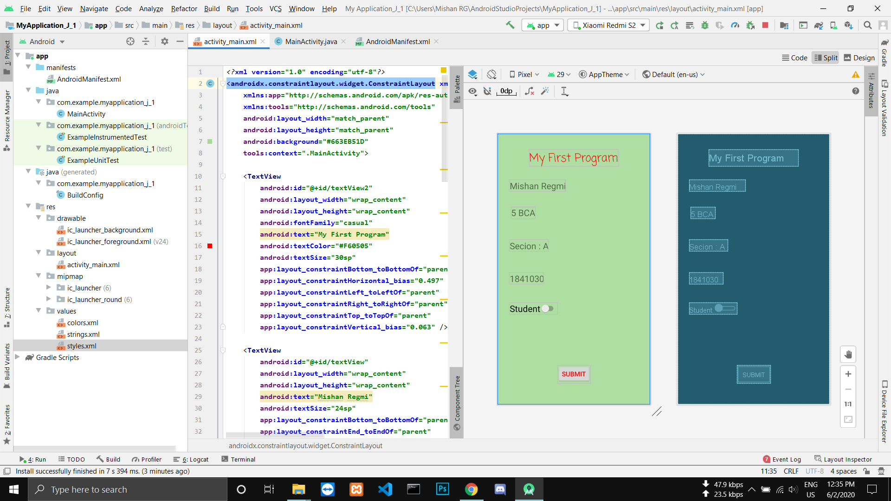

App On Phone Screenshot

